|  |  |
| --- | --- |
| Assignment Date | 21 September 2022 |
| Student Name | Ms. GOPIKA R |
| Student Roll Number | 910619104022 |
| Maximum Marks |  |

**ASSIGNMENT 2**

**Data Visualization and Pre-processing**

**1.Download the dataset:**

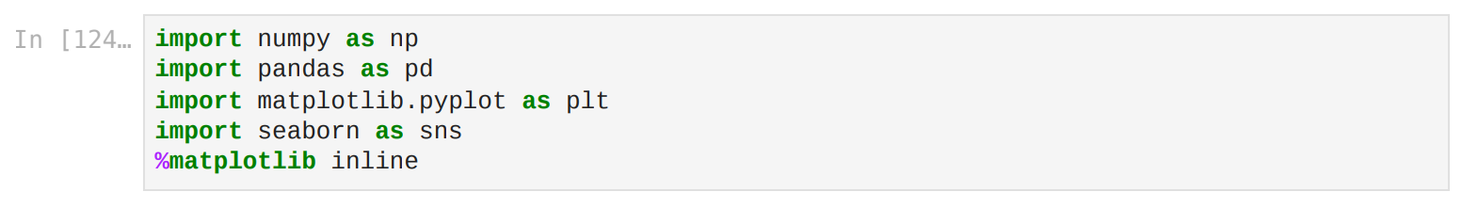

**2. Load the dataset.**

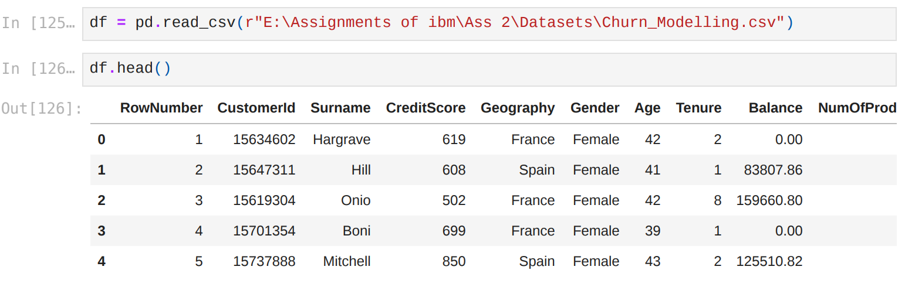

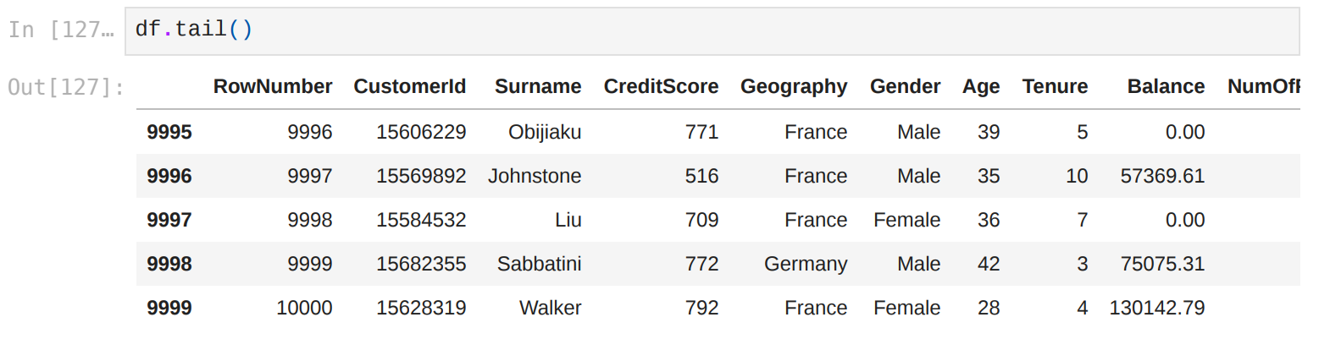

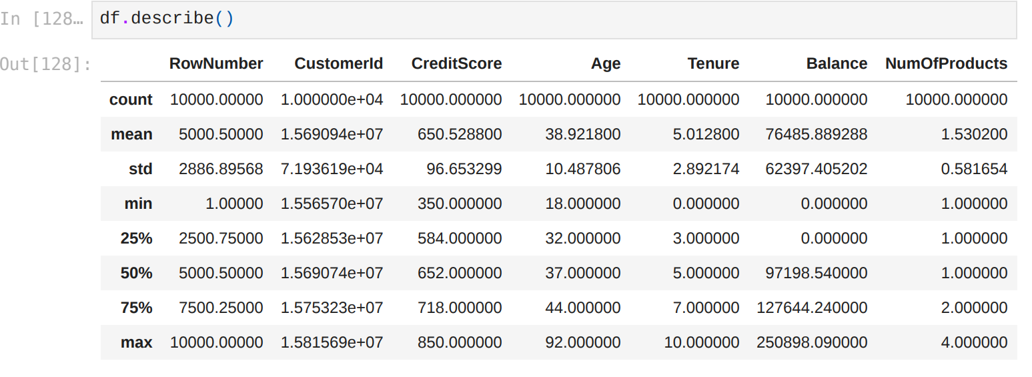

**3. Perform Below Visualizations.**

**Univariate Analysis:**

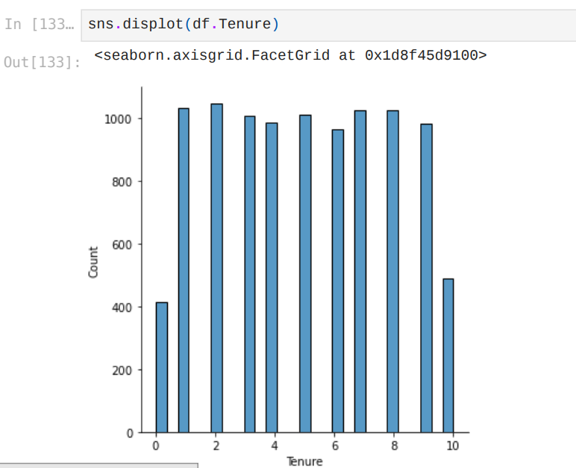

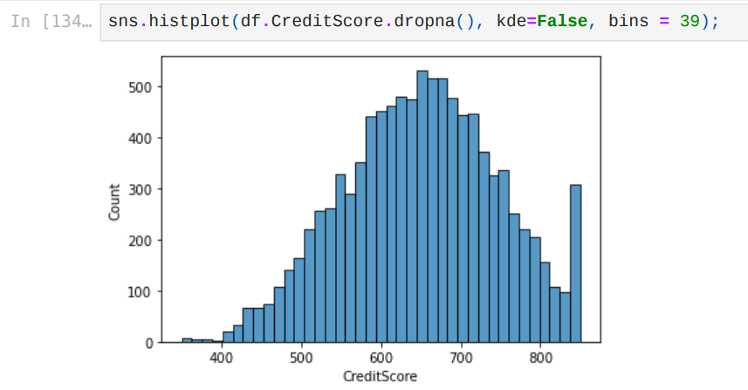

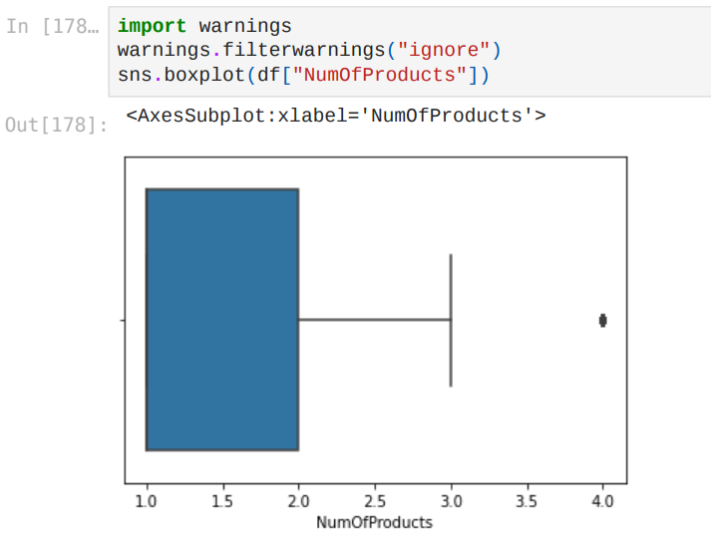

**Bi - Variate Analysis:**

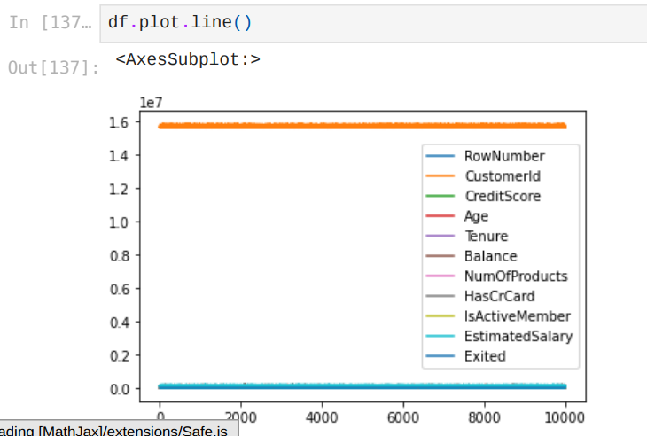

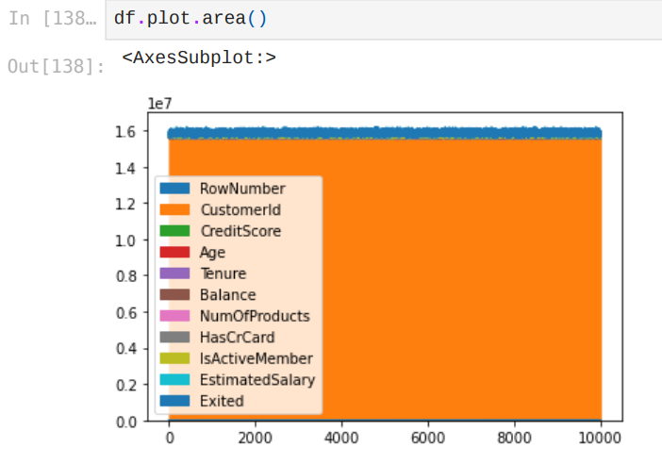

**Multi - Variate Analysis:**

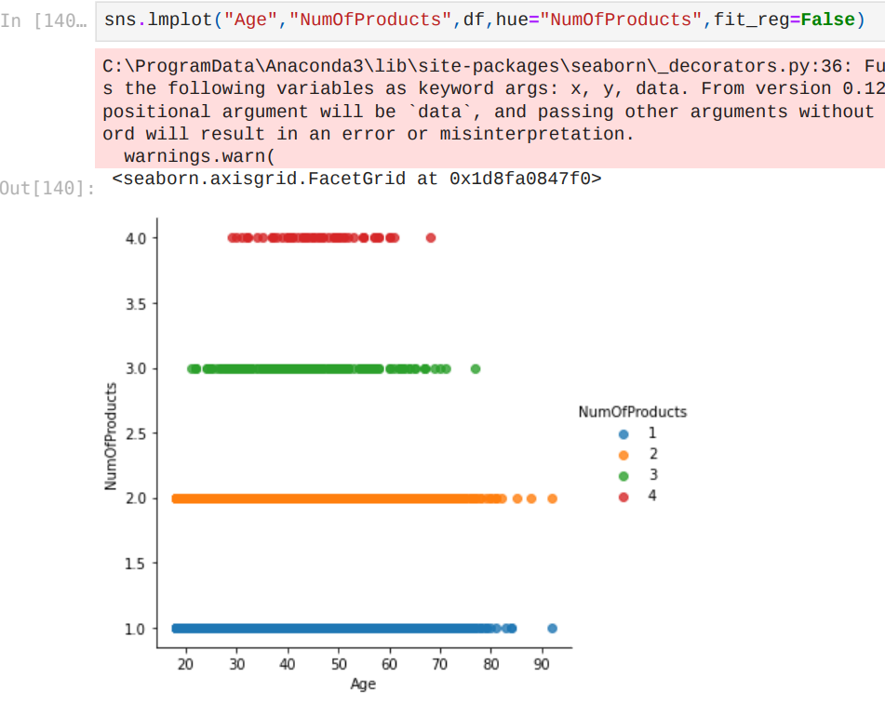

**4. Perform descriptive statistics on the dataset.**

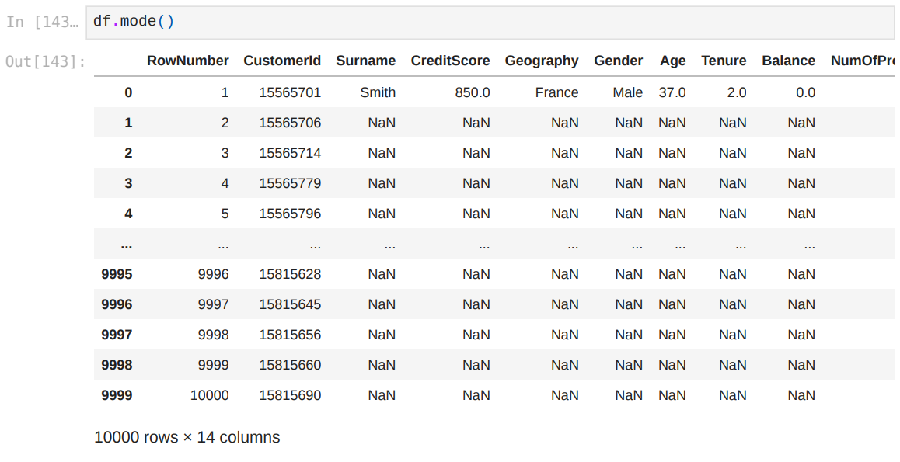

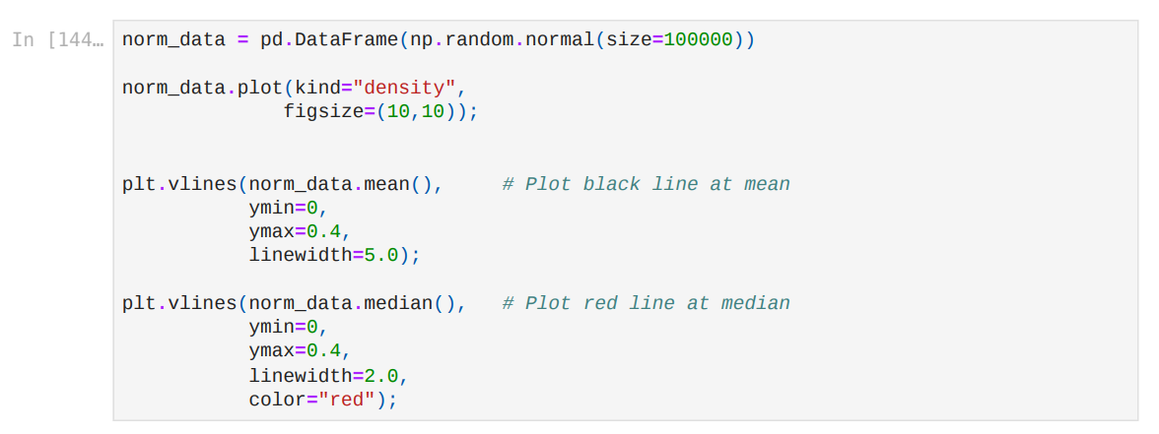

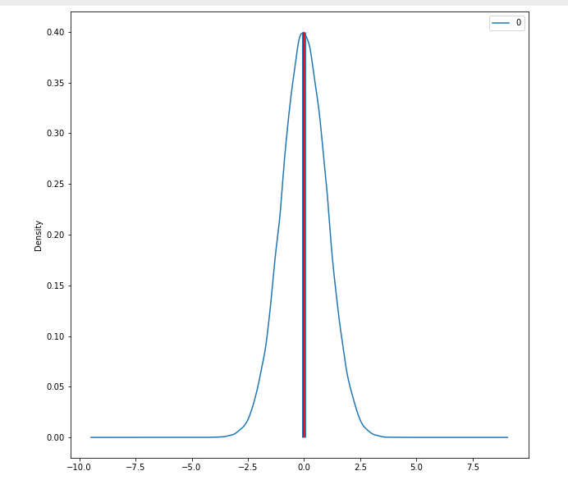

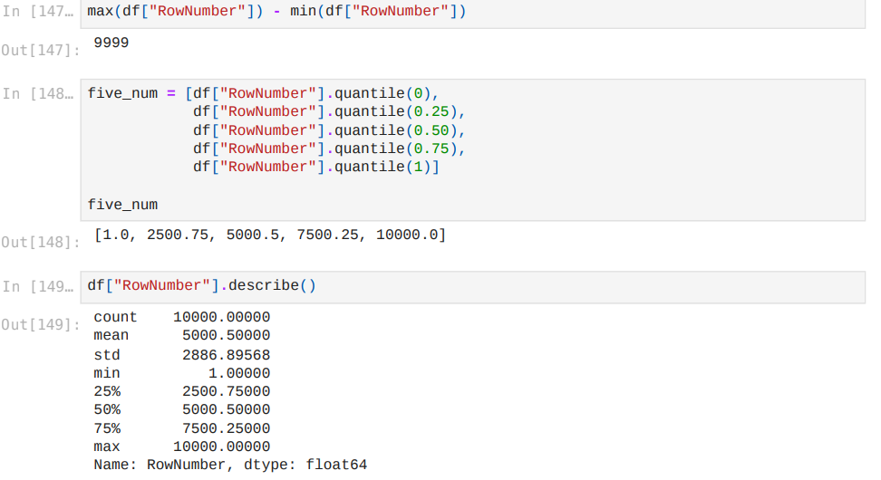

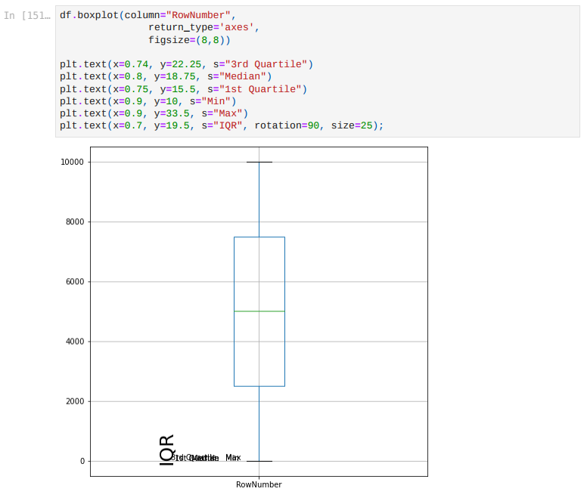

**5. Handle the Missing values.**

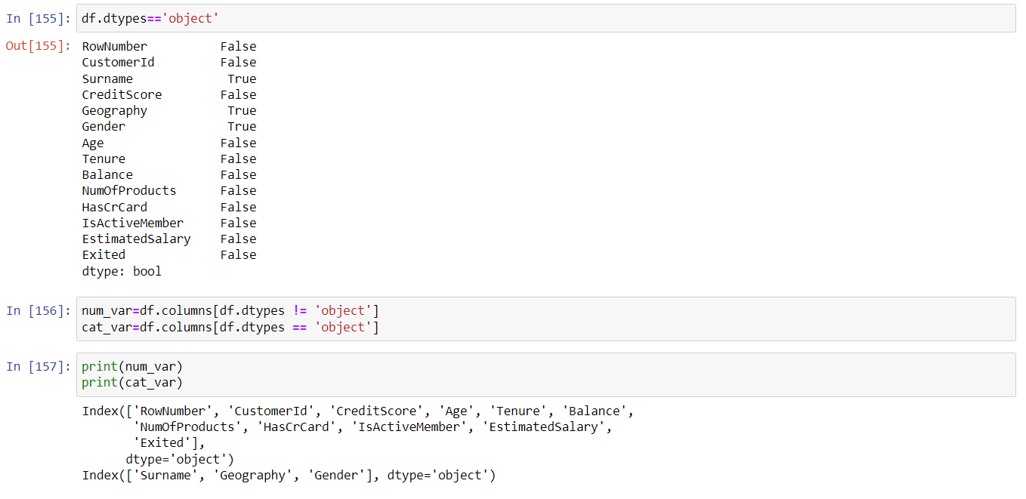

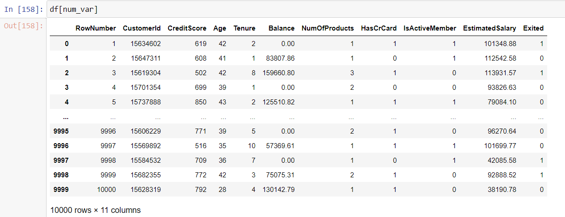

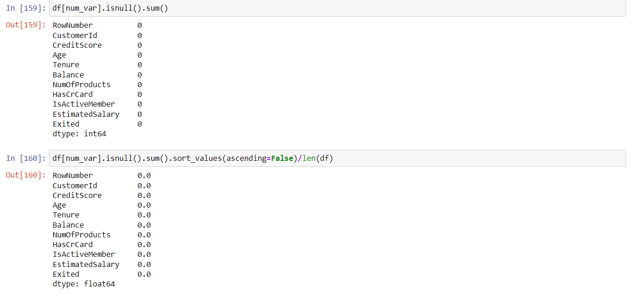

**6. Find the outliers and replace the outliers**

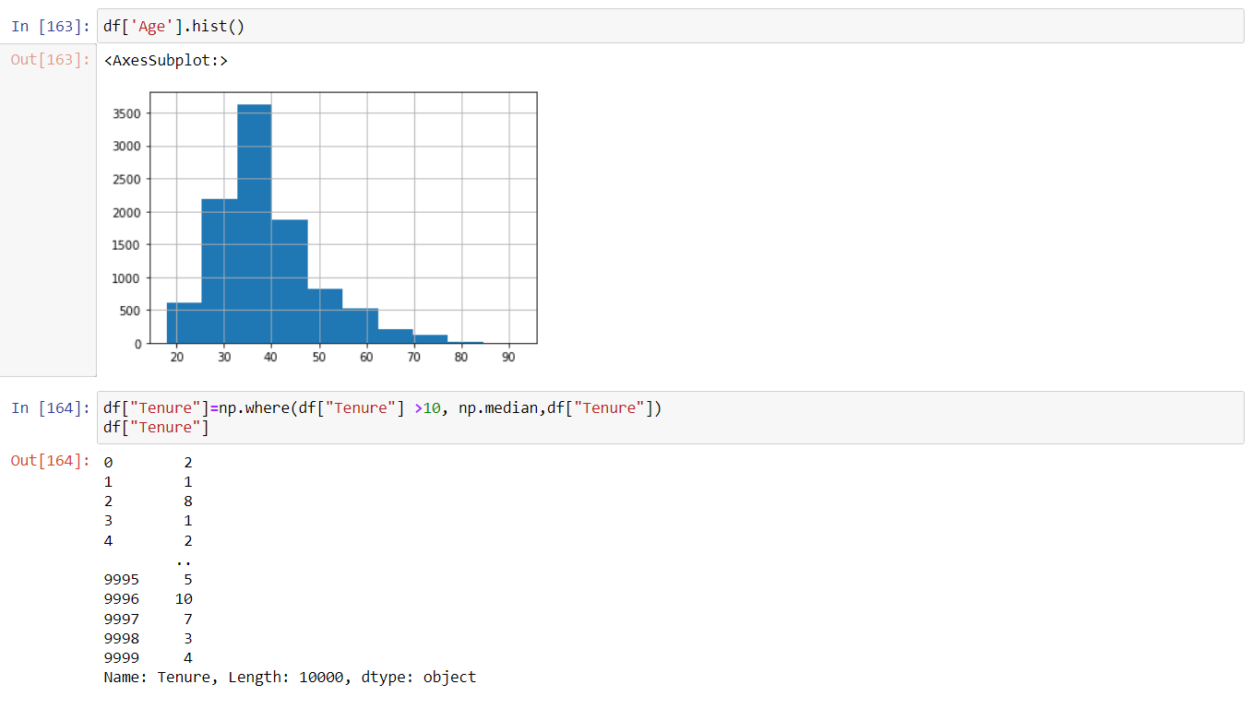

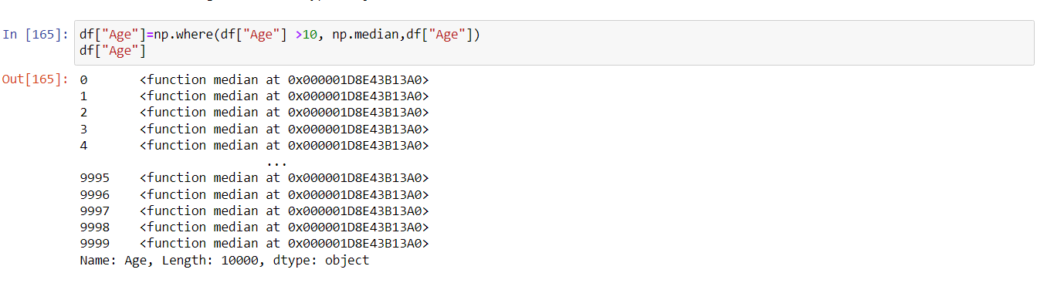

**7. Check for Categorical columns and perform encoding.**

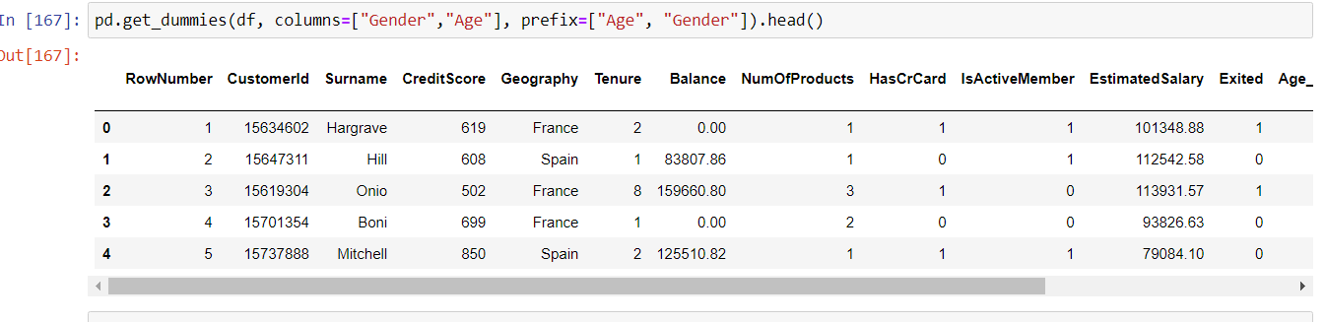

**8. Split the data into dependent and independent variables.**

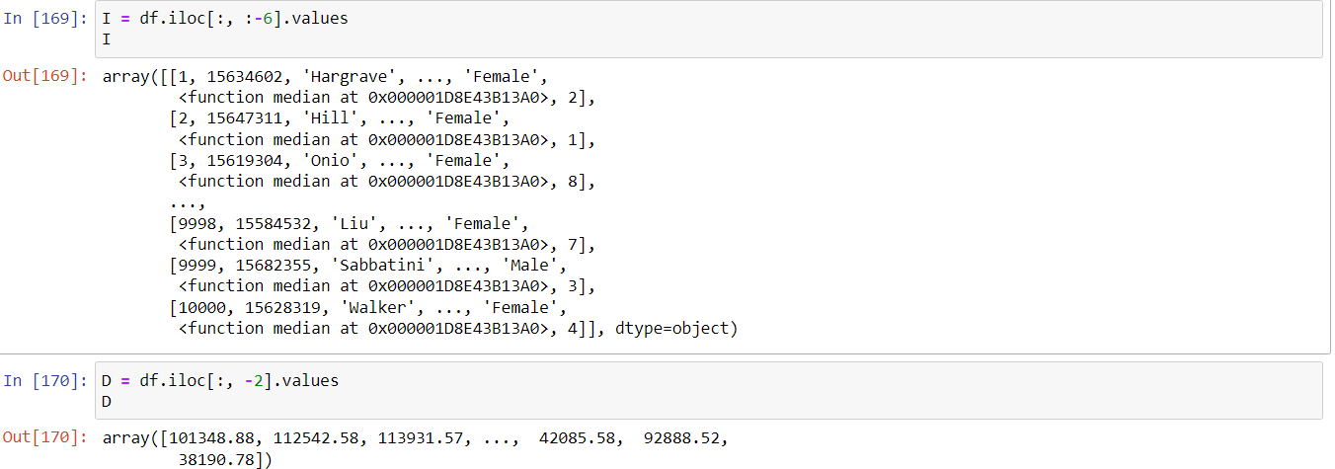

**9. Scale the independent variables**

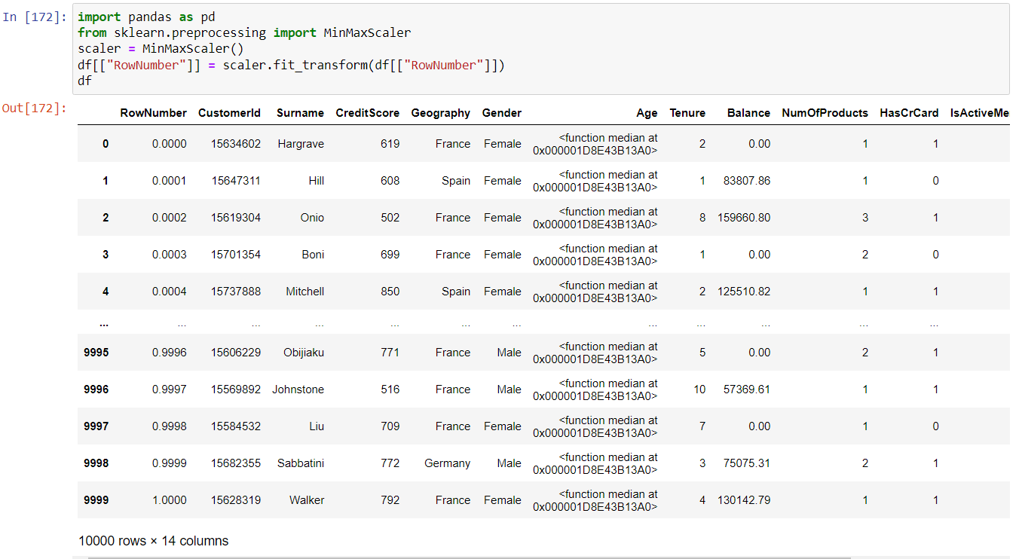

**10. Split the data into training and testing**

